Setting up one Agent
- Login to your linux machine.
- Go to Dynatrace platform ,and click on OneAgent tab
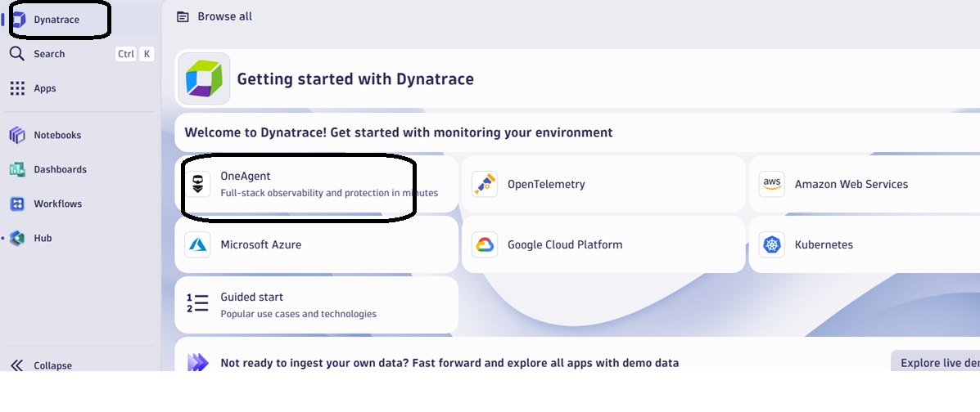

- Click on Setup
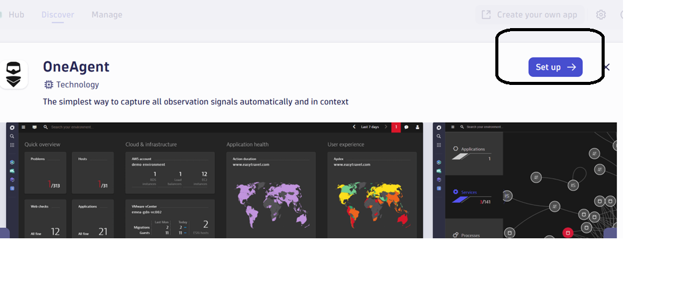
- Click on generate token
On same page you will find all the three links, perform it

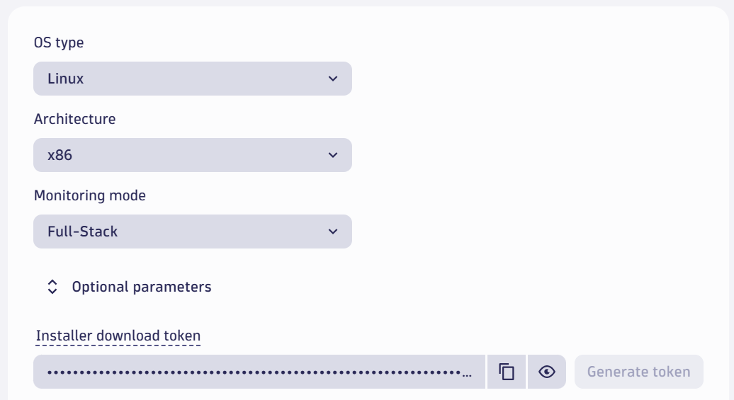

Perform steps
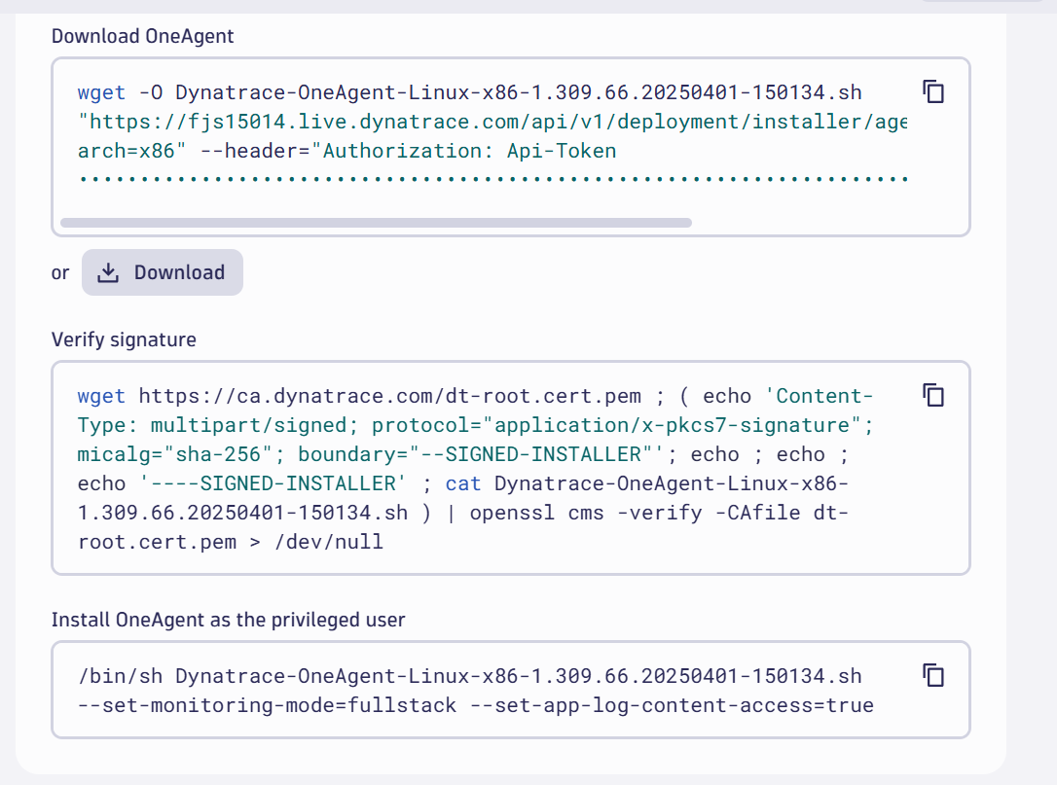

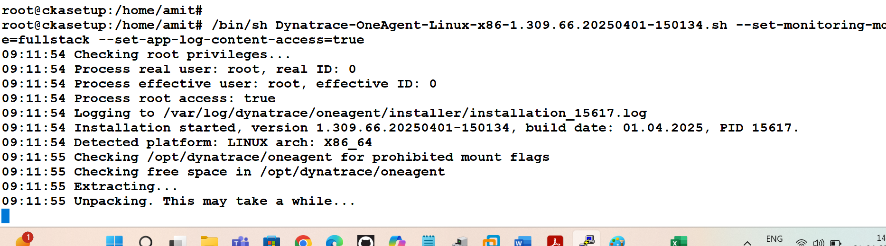

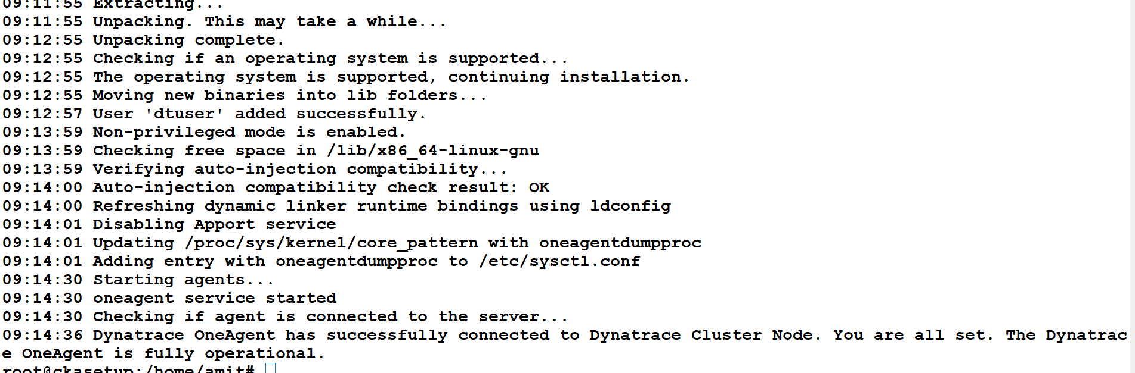

Go to App folder and search for host
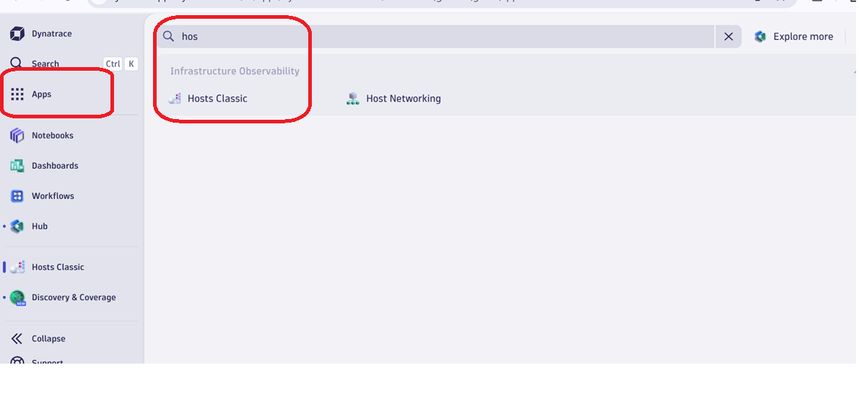

Find the host
